**Work Based Learning Checklist**

<http://www.hisdcareerreadiness.org/prepare/wbl-work-based-learning/>

⎕ **Practicum – UNPAID Training Plan (Offsite Location only)**

**Training Plan complete PRIOR to students starting offsite work**

**Training Plans to CTE Department: 5 days after student begins   
offsite work**

1. Submit: Original signed Training Plans with TEKS and Transmittal Form
2. 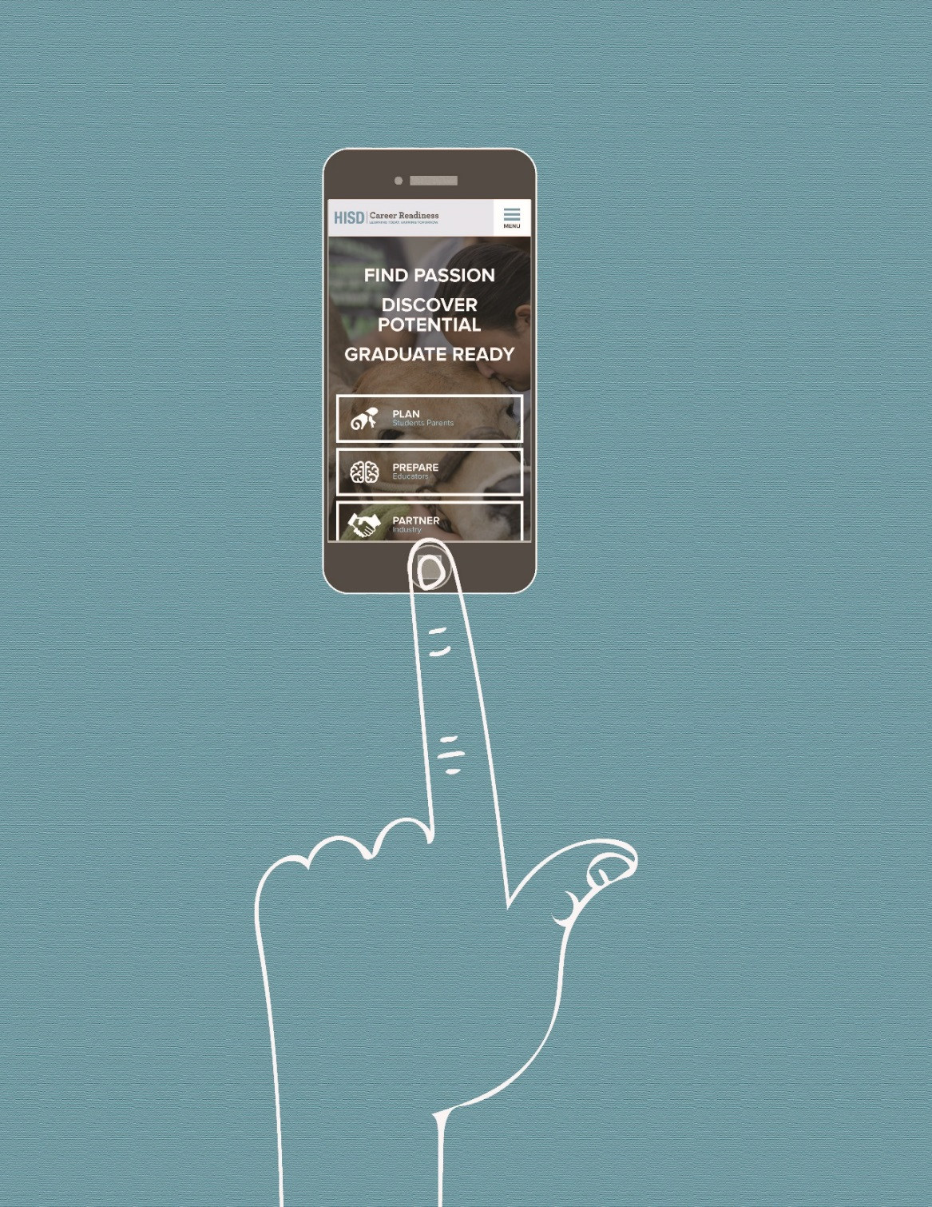Keep 3 additional copies of training plan for (1) Campus (2) Workplace   
   (3) Student

⎕ **Practicum – PAID Training Plan**

**Student Job Placement Deadline: Tuesday, September 13**

**Training Plans to CTE Department:** **Tuesday, September 20**

1. Job assignment is within Program of Study
2. Submit: Original signed Training Plans with TEKS, Child Labor Law and Transmittal Form
3. Keep: 3 additional copies of training plan and documentation for (1) Campus   
   (2) Workplace (3) Student

⎕ **Career Prep – PAID Training Plan**

**Student Job Placement Deadline: Tuesday, September 13**

**Training Plans to CTE Department: Tuesday, September 20**

1. Job assignment in Program of Study or other industry as necessary
2. Submit: Original signed Training Plans with TEKS, Child Labor Law and Transmittal Form
3. Keep: 3 additional copies of training plan and documentation (1) Campus   
   (2) Workplace (3) Student

⎕ **Complete WBL Training for Career Prep/Practicum Teachers**

⎕ **6-Weeks Onsite Visit Log - Due 5 days after close of each 6-weeks**Complete 6-weeks visitation log, including comments and signatures from each work location

⎕ **Change in Work Location – “Change of Training Station Form”**

If a student changes jobs, *new training plan must be completed.*

Student must find a new job within 15 school days or be removed from the

class Change of Training Station documentation submitted to CTE District

Office within 5 days of placement to new work location.

**Upon receipt WBL Plans are reviewed, originals are filed at the District Office.**

**Copies at campus for (1) School Files (2) Workplace and (3) Student/Parent**

Career Preparation and Practicum courses must span the entire school year; students may not be enrolled at mid-semester unless they transfer from a school where they were enrolled in the same course. It is a campus decision to withdraw a student at mid-semester because they need to be enrolled in other courses.